Is the Current Infrastructure of the Utrecht Heuvelrug Region Adequate for Meeting

the 4 Mobility Targets Set Out to Achieve Climate Neutrality by 2035?

Sebastian Fortineau (7096364), Kam Wo Lau (4156016), Timo Schortinghuis (6775799), Madeline Semeleer (7020929), Archie Redman (5547899)
Global Sustainability Science, Utrecht University
GEO1-2416: Regional Integration Project
Brett Petzer
June 21, 2021

Is the Current Infrastructure of the Utrecht Heuvelrug Region Adequate for Meeting

the 4 Mobility Targets Set Out to Achieve Climate Neutrality by 2035?
Fossil fuels are one of the main sources of greenhouse gas emissions, which contribute to global climate change. In the Netherlands, more than 40% of oil production is used in the transportation sector, which is the highest consumption sector of oil in the country, as can be seen in Figure 1. It is necessary to implement an energy shift to lower the negative externality of fossil fuel consumption if society wants to live sustainably, especially in the transport sector.
Figure 1
Purpose of Consumption for Different Energy Sources in the Netherlands (IEA, 2018)
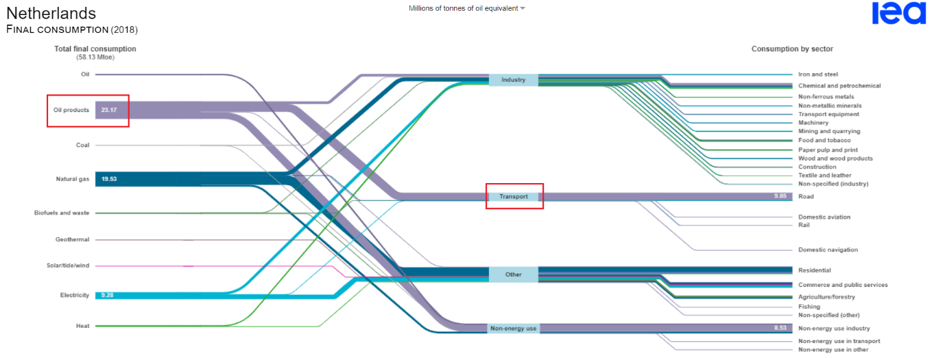
“Climate neutrality” refers to the net phase out of all greenhouse gas emissions (Höhne et al., 2015). In order to achieve climate neutrality by 2035, the municipality of Utrecht Heuvelrug has four targets that would enable them to renew their vision of transportation through a modal shift. These are (1) reduce motorised traffic; (2) induce a modal shift from private cars to public transport and cycling; (3) shift to 75% of private cars being electric; (4) shift to the remaining 25% of cars using biogas (Putman & de Wit, 2017). This paper will investigate and establish whether the current infrastructure of the Utrecht Heuvelrug region is appropriate to deal with a fundamental shift in mobility to facilitate climate neutrality by 2035. This will be done through evaluating the current sustainable mobility plans, exploring the infrastructure in the region, and discussing the human response to such a modal shift.
Biogas is an emerging niche in sustainable mobility. It refers to the type of renewable energy which can be extracted from decomposed organic matter, e.g., natural residues of dead plants and crops. It can also be released from the solid residue in landfill, anaerobic digestion of sewage, manure and similar organic material (de Almeida D'Agosto, 2019). In addition, biogas can be obtained from biomass that would be converted to the form of bioethanol or bioelectricity in the later stage (d'Amore, F., & Bezzo, F., 2016).
The Multi-Level Perspective will be used as the analytical framework to examine the socio-technical system of mobility. The current status of the energy transformation process and sustainable mobility plans of the municipality will be studied. In addition, existing infrastructure, including electric and biofuel charging facilities, public transportation systems in the region and more sectors will be investigated. Finally, potential externalities of electric and biofuel vehicles will be discussed.
In order to appreciate the transition plan from a social sciences perspective, several stakeholders will be taken into account. First, the behaviour of residents, frequen road users and businesses in the region will be considered as they are the main target groups for an eventual behaviour change. Second, the behaviour of tourists will be studied since they can have a direct and significant impact on the area.

Literature Review
Existing Research
Infrastructure
During the research, ‘Infrastructure’ was defined as all cycling lanes, roads, walking paths, street lights, car and bike parks, public charging stations for both electric and biofuel cars, and all other public transport infrastructure. The province of Utrecht is one of the best places in all of Europe for cycling, and the infrastructure is outstanding in terms of efficiency, however, many improvements in terms of safety can be made in order to incentivise cycling even further (Provincie Utrecht, 2016). Furthermore, the public transport in the region should be improved; most importantly are connections between bus lines and train stations ( buses need to be faster and more efficient). Moreover, there have been parking problems at public transport stations, for both cars and bicycles (Vlug, 2010). At last, to incentivise electric and biofuel vehicles, it is important to create more public charging stations within the region (European Federation for Transport and Environment AISBL & Todts, 2020).
Emissions
During the research, ‘Emissions’ was used to refer to all the greenhouse gas emissions vehicles emit. According to the Centraal Bureau voor Statistiek (CBS, 2012) newer cars produce significantly fewer emissions in comparison to relatively old cars. However in the Netherlands, most cars are between 9 and 15 years old, which means it will take another decade before ‘cleaner cars’ can have an impact on the national scale.
There is a train of thought that believes a switch to electric and biofuel vehicles will solve the climate crisis, however, this is wrong. Electric and biofuel vehicles are not completely emissions free, since the production of these energies in the first place emits greenhouse gases (d'Amore, F., & Bezzo, F. 2016). In addition to this, society is locked-in and built around the fact that the vast majority of vehicles use petrol as the main type of fuel for transport (Unruh, 2002).
Current Situation
Both nationally and regionally, the main mode of transport is fossil-fuel cars. In the region of Utrecht Heuvelrug, the proportion of fossil-fuel cars is lower than the national average, however it remains high at about 80% (Gemeente Utrechtse Heuvelrug, 2020; Statista, 2021). In addition to this, the number of electric vehicles (EVs) in the Netherlands is rising exponentially and the percentage of EVs sold is rising even faster (Stastista, 2021). Most of the people willing to buy EVs are relatively young and most often well informed people; this latter factor remains one of the most important factors regarding the willingness of buying EVs (Harrabin, 2018; Kreps, 2020).
Possible Future
Both biofuels and electricity have great potential for a more sustainable future, especially in the region of the Utrecht Heuvelrug ((International Renewable Energy Agency, 2021) & (Gemeente Utrechtse Heuvelrug, 2010).
In order to realise a shift towards a sustainable future, the mindset and behaviour of people need to change, so that people can become better informed (Gyimesi & Viswanathan, 2011). Once mindsets have changed, the region will need to undertake major improvements in sustainable infrastructure in order to reach the set targets, and potentially become one of the prime examples of a sustainable community within Europe (European Federation for Transport and Environment AISBL & Todts, 2020).
For a more in-depth analysis of our literature review, see appendix 1.
Missing Research
Infrastructure and Current Situation
There is limited information about how many people use public transport on a daily basis, and how many people have access to public transport in the region. There is also little information about the road safety for cyclists and cars, and the distribution of different types of vehicles within the region.
Emissions
There is limited information about the emissions by transport vehicles in the specific region. Information about how electricity needed for electric cars will be generated in the area is scarce.
Potential Future
There is a complete lack of information about the willingness of residents and tourists in the region to shift away from fossil-fuel cars to other modes of transport. Also there is no information about what needs to change according to residents and tourists to make this shift possible. Information about the feasibility of the plans and targets set out by the municipality of Utrechtse Heuvelrug is missing.
Chosen Research Frameworks and Systems
The Multi-Level Perspective is used as it is ideal to analyse socio-technical systems such as the infrastructure and transport systems. Backcasting is used as it allows to set goals and then research how to reach them. QGIS is used to analyse geomatic data. Surveys were used to collect qualitative data on opinions and the current situation in the area. Fieldwork was used to collect quantitative data on missing numerical data in the region.
Methods
The Multi-Level Perspective
One of the methods chosen is the Multi-Level Perspective (MLP), which helps in the detailed study of socio-technical systems (Geels, 2020). Socio-technical systems outlook at the two-sided interrelationship between society’s complex infrastructures and human behaviour (Rophol, 1999).
There are three different levels within societal systems which are recognised in the MLP: niches, where radical innovation emerge; the regime, which consists of dominant institutions and technologies; and lastly, the landscape, which represents large-scaled trends and circumstantial drivers and barriers to change (Withmarsh, 2012). Going in a more sustainable direction requires a change in the current systems which, in turn, calls for a change in the elements within the system.
The elements found during the research that compose the niche are: new technologies (e.g. biofuel cars); institutions; markets (e.g. for electric cars or electric bikes); and lifestyle and cultural elements. Furthermore, the niche level consists of networks of actors and organisations (Nykvist, 2008).
According to Kykvist (2008), there are seven components that make up the regime, namely: technology, infrastructure, techno-scientific knowledge, markets and user practices, cultural and symbolic meaning, sectoral policy, and industry. Nykvist also says that the actors within the regime, through incremental change, are guided to further improve the current system using the capacities and resources of dominant players. A focus of the research will be on sectoral policy which is the responsibility of the municipalities in the region of Utrechtse Heuvelrug. The concerned municipalities are listed in the table below, Figure 2. The research will also seek to find the ecological and cultural conditions in which the regime may be well suited to fulfill the functions needed to accomplish the four climate neutrality targets of the region. This represents the landscape level of the MLP.
Figure 2
List of Municipalities, Towns, Cities, and Villages Within Municipality
# | Municipalities | Towns / cities / villages within municipality
1 | Soest | Soest, Soesterberg, Soestduinen
2 | Zeist | Zeist, Bosch en Duin, Austerlitz
3 | Leusden | Leusden, den Treek, Oud-Leusden
4 | Utrechtse Heuvelrug | Driebergen-Rijsenburg, Doorn, Leersum, Amerongen, Maarn, Overberg, Maarsbergen
5 | Veenendaal | Veenendaal
6 | Rhenen | Elst, Remmerden, Rhenen
7 | Amersfoort | Amersfoort

The main change in a system occurs between the regime and niche level of the MLP, where these changes can be synergistic or antagonistic (Withmarsh, 2012). Moreover, the MLP is a valuable tool for stakeholder analysis. The MLP discerns regime and niche actors who may be seen to behave in different ways and offer contrasting views on societal problems of unsustainability. The MLP thus offers a way to analyse the tensions between niche and regime actors, and to establish any possible synergies.
The MLP is a good fit for the report considering that it aims to analyse possibilities of future technologies that are still in their developing stages. However, using the MLP does come with possible drawbacks which have been considered during the use of this method. The MLP framework has been derived mainly by analysing historical transitions. Historical transitions, in most cases, involved a transition to a different but also to a greater consumption of technical innovations and of resources (Withmarsh, 2012). This report focuses on a sustainable transition within the transport domain in the region of Utrechtse Heuvelrug. A sustainable transition such as this is likely to be a transition to less consumption, rather than more.
Fieldwork
In order to gain more detailed data relating to the area of research and fill any gaps found during the literature review, a survey was conducted. The aim of this survey was to collect qualitative data on the current behavioural habits and patterns of people travelling within and around the Utrecht Heuvelrug region, and to collect their opinions on the current state of infrastructure in the area. In order to do this, a series of surveys with largely similar sections was devised, but with more specific questions on the form of transport that the participants had used to reach the Utrecht Heuvelrug that day. The questions within the surveys were then chosen in order to provide an insight into the potential areas limiting the transition to climate neutrality. Therefore, questions were asked about people's perception of alternate modes of transport, to see if this is a limiting factor in conjunction with questions that focus on the level of infrastructure within the region.
To gain adequate data on people’s perceptions, open questions were used as it allows a wider array of answers that we may not have seen using multiple choice questions. Whereas, multiple choice questions were used when asking about the number of times a certain mode of transport is used in a week and the perceived adequacy of the infrastructure region. Multiple choice questions allowed us to gain concise uniform data that is easier to process and analyse without reducing credibility. ArcGIS Survey123 was used to conduct the surveys. The data was then analysed using SPSS. In addition to the data collected during this fieldwork, this report was also supported by other fieldwork conducted by other groups of the Regional Integration Project course, notably group 5D.
Furthermore, as part of the research, fieldwork was conducted to collect data on the quantity and type of vehicles in different locations. These were chosen by using a stratified sample of busy areas in the region; a selection of restaurants, car parks, or any other public facility which could be used just as much by residents of the region as by tourists. The national park was stratified into four sections from North to South. One region would be randomly chosen from each strata. The randomization process was conducted by Microsoft Excel. At first, Region 7, 19, 37 and 46 were randomly chosen for sampling. After further research on the randomly selected regions, our team decided to strategically shift the targeted survey region from 46 to 41. It is because region 46 has no representative infrastructures (e.g. restaurant, car park, gas stations) that can have sufficient flow of road users or visitors to generate meaningful data. Thus, region 41 is chosen because of the geographical proximity and the representative infrastructures within the region (Figure 3). This data was used in conjunction with the surveys conducted to identify potential shortfalls in the infrastructure of the region.
Figure 3
Randomised Stratified Sampling (QGIS)
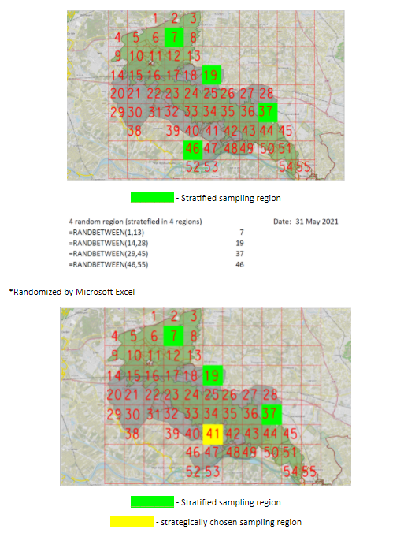
Results
MLP Results
Following the MLP model explained in our methods section we can categorize the different aspects of our research in 3 levels: the landscape level, the regime level, and the niche level.
The landscape level contains a climate neutral ‘landscape’ where the 4 targets of our met. The regime consists of the infrastructures and technologies needed to make this landscape possible. Furthermore, it consists of the main actors involved in assuring these targets are met namely, the municipalities in the region. Lastly the niche level consists of the new technologies that can be used to meet these targets and the perception of people regarding possible changes in mobility. In Figure 4 you can see how the presence of the elements in the niche level affect the elements in the regime level which inturn will have its effect on the landscape level.
Figure 4
Multi-Level Perspective Diagram for Sustainable Mobility in the Region
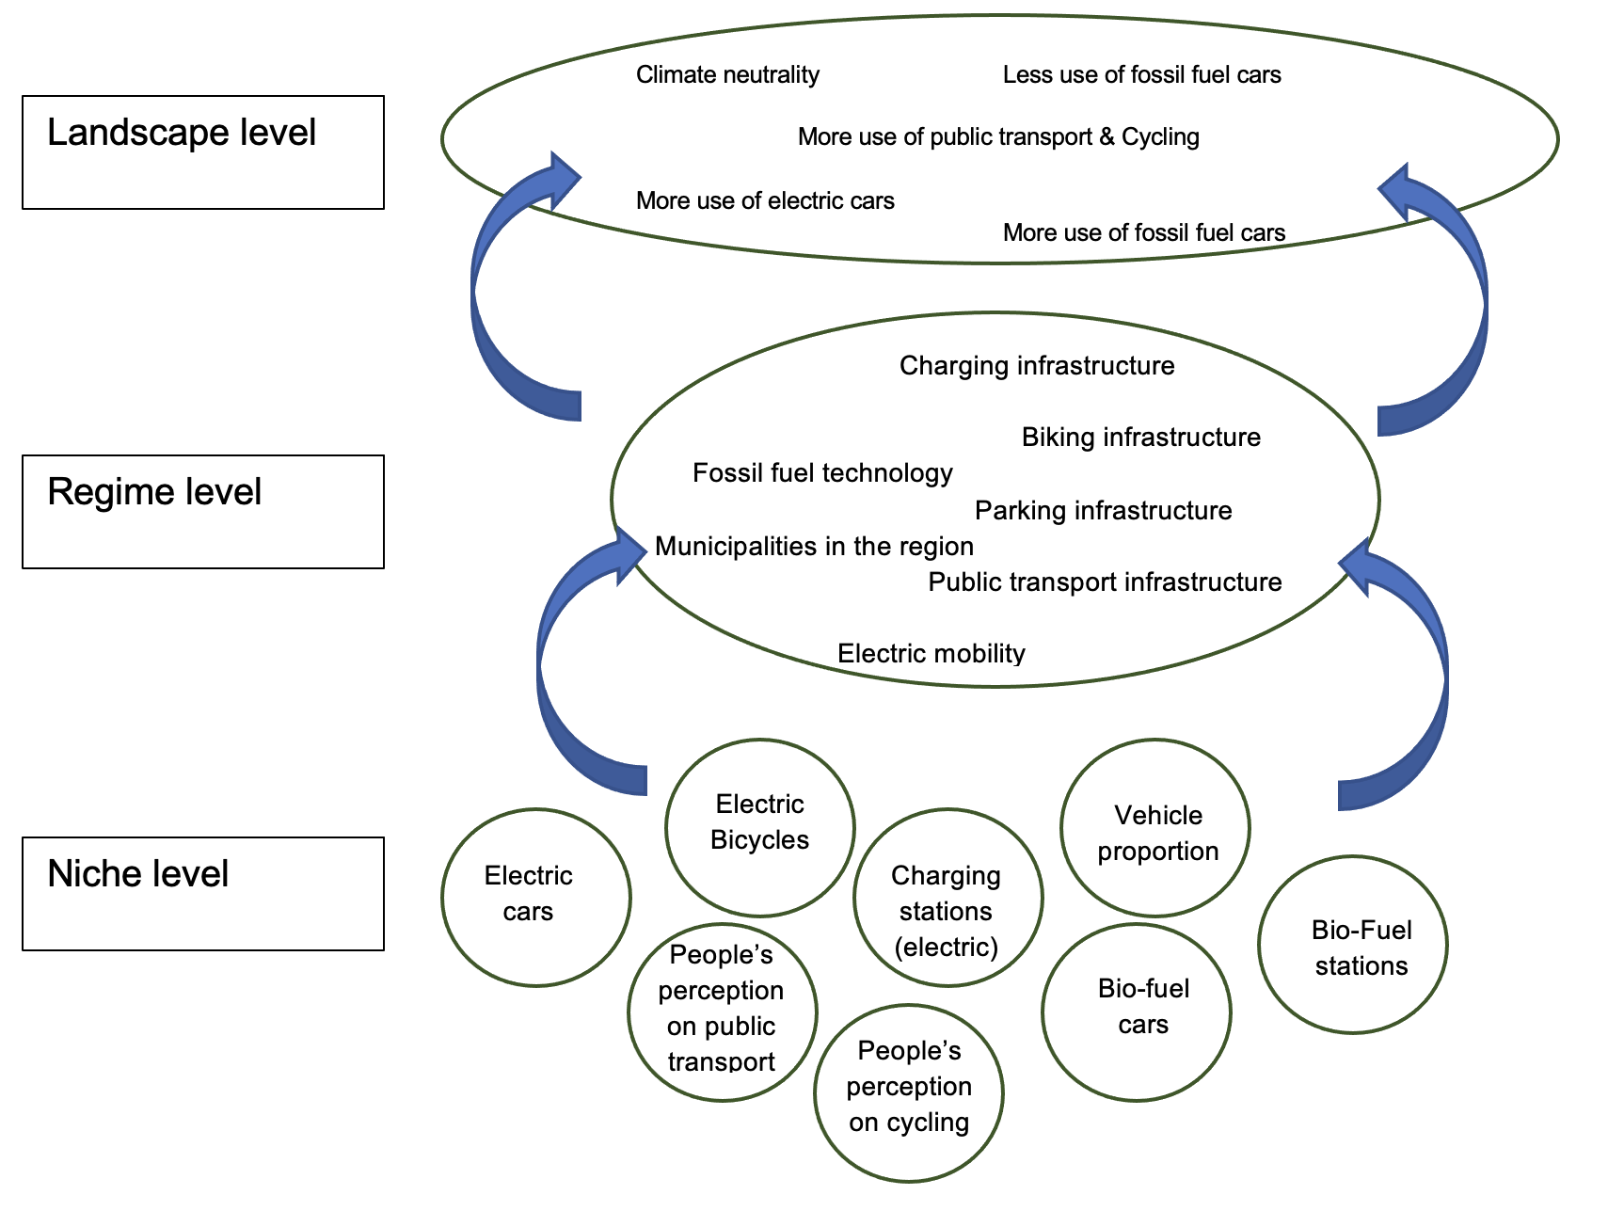
Survey Results
The results collected from the survey undertaken by some members of the group were not as conclusive as was hoped. However, some patterns are very clear and patterns have emerged.
The majority of fossil-fuel car owners reported that it was neither practical or efficient to use public transport, they reported barely or never using it, since it is neither quick or efficient. There was a split decision on public transport reliability.
Relating to cycling, fossil-fuel car owners said it was too much effort to use a bicycle, since it was too far to cycle to the region or the park. Most users reported using their bicycles very often back home. All users had a positive attitude towards cycling, reporting it as “efficient, quick, and reliable”.
All users of motorised transport, defined as any vehicle which contains an engine to power it, reported that they considered their mode of transport very practical, efficient and reliable. These three terms appeared repeatedly in our results, showing a strong preference in users attitudes and behaviours towards these three factors.
In terms of biogas vehicles, none of the people interviewed owned one. Over 90% of respondents reported having never heard of biogas vehicles before, and had no clue what this meant.
All cycling users had a consensus that their mode of transport was efficient, “good for the planet”, and quick. A majority of bicycle users stated that they also owned motorised vehicles, such as fossil-fuel or electric cars, but that they did not use them that often.
Regarding the use of electric cars, the survey showed that the initial purchase price of electric cars is too high to warrant the switch from fossil-fuel cars, even if there are perceived long term financial and environmental benefits. This outcome supports previous research by Gyimesi and Viswanathan which similarly found participants of their survey did see the sustainable benefits of using electric cars but were not interested due to the high price (Gyimesi & Viswanathan, 2011). Furthermore, the data also highlighted the dismalness of participants to electric vehicles as a result of perceived practicality issues. In conjunction to studying the barriers to switching, the survey also looked at the potential reasons as to why people may switch to electric cars. The results of the survey showed that the overarching response was that people would switch for environmental reasons. However, of all the respondents, only one had actively considered switching to an electric car before.
In addition to these results, the research conducted offered a few datasets which are useful to this report. Figure 5 shows the willingness of people in the Netherlands to take public transport instead of the car. A large part of people say they already do so with 35%, however the majority (39%) do not do so; they either are willing but not currently doing so, maybe willing to do so, or not willing to do so.
Figure 5
People’s Willingness to Take Public Transport Instead of the Car in the Netherlands
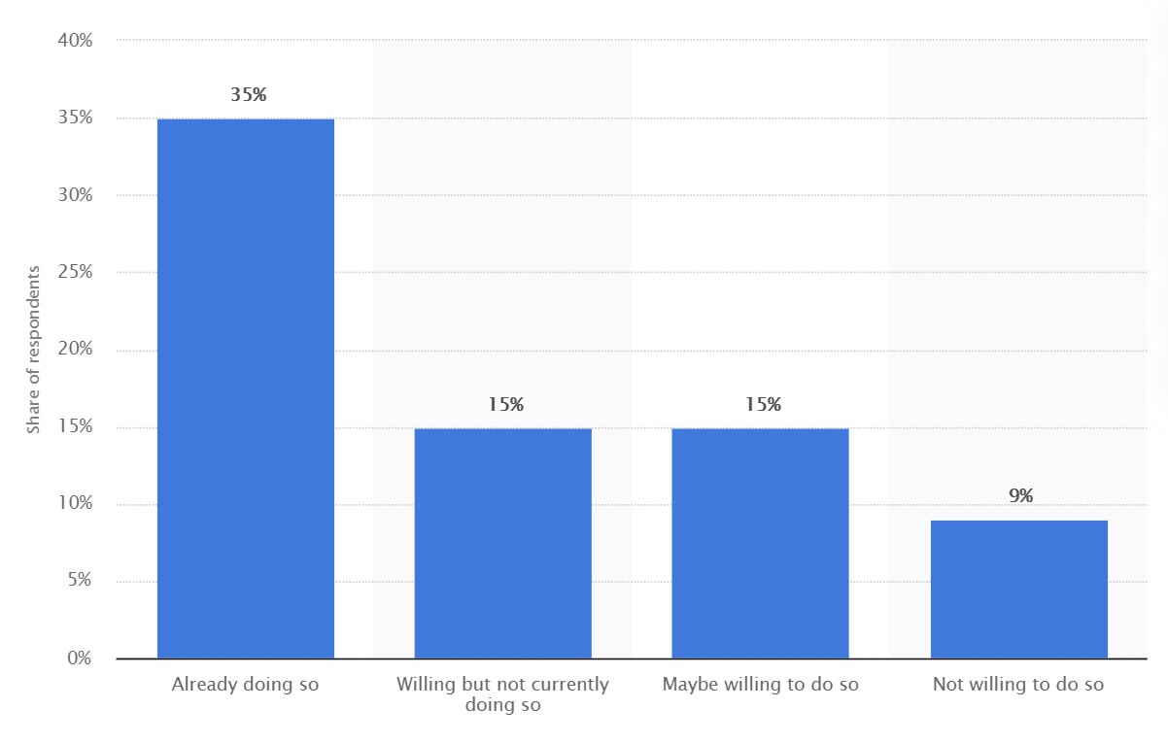
Fieldwork Results
The results collected through the counting of vehicles fieldwork allowed many conclusions to be made. Figure 6 shows the mean value for each type of vehicle, counted across the different locations. By looking at this data and more particularly at the standard deviation, it is clear to see this dataset is not perfect. A high standard deviation for most categories indicates the results collected were not very accurate, and a low standard deviation for other values can be explained by a low number of individuals.
Figure 6
Table Showing the Mean, Standard Deviation, and Range Values for the Types of Vehicles in the Region (SPSS)
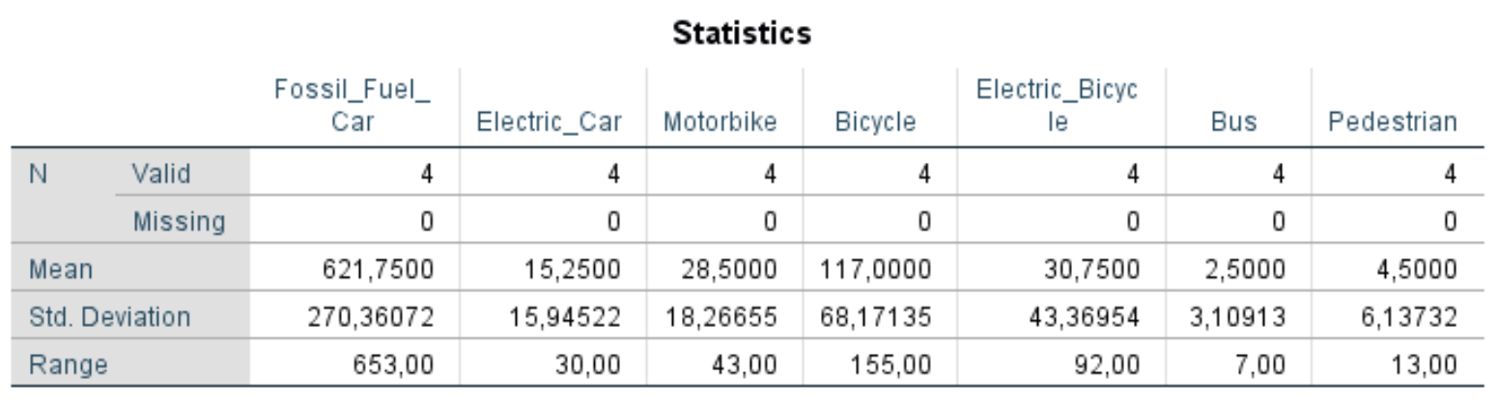
Figure 7 shows the same results but in a pie-chart format. This allows to highlight the dominance of fossil-fuel cars in the region, with the next mode of transport being bicycles. The majority were driving fossil-fuel cars (73%), followed by bicycles (14%), electric bicycles (6%), motorbikes (3%), electric cars (2%), and pedestrians (1%).
Figure 7
Pie Chart Indicating the Proportions of the Modes of Transport in the Region (SPSS)
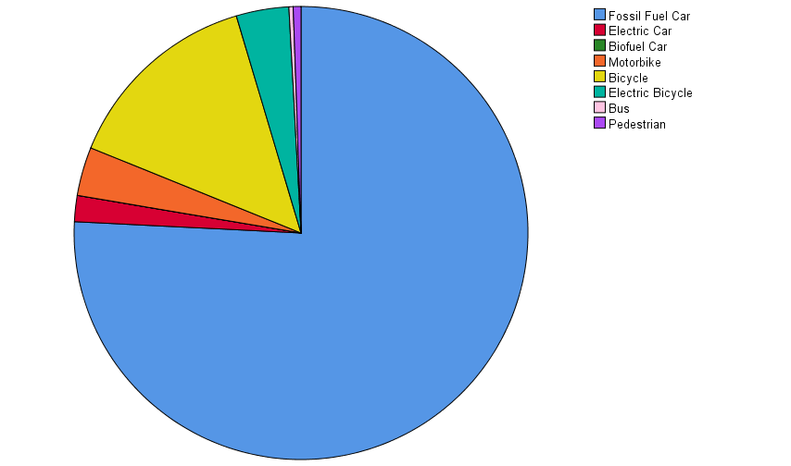
This data also showed that 78% of users used private motorised vehicles, such as fossil-fuel cars, electric cars, and motorbikes, The other 21% used non-motorised vehicles such as bicycles, electric bicycles, public transport or walking.
In combination with the data collected during the fieldwork, research has been found to support claims made in this report. For example, Figure 8 shows the emissions to air on Dutch territory for road traffic, in total and by type of vehicle. It can be seen that emissions have decreased drastically since 1990 (192.97 million kgs of total emissions) to 2018 (27.45 million kgs).
Figure 8
Emissions to Air on Dutch Territory by Road Traffic (Statista, 2021)
Furthermore, data regarding the sale of passenger cars was found to help with the analysis and to support the fieldwork. Figure 9 shows the passenger car sales in the Netherlands by year since 2010, and shows a slight decrease, with a recent increase since 2016. In combination with Figure 10, this can be explained by a rise in electric vehicle and hybrid sales. Figure 10 highlights the percentage of units sold for passenger car sales in the Netherlands by fuel type and by year since 2010.
Figure 9
Passenger Car Sales in the Netherlands (Statista, 2021)
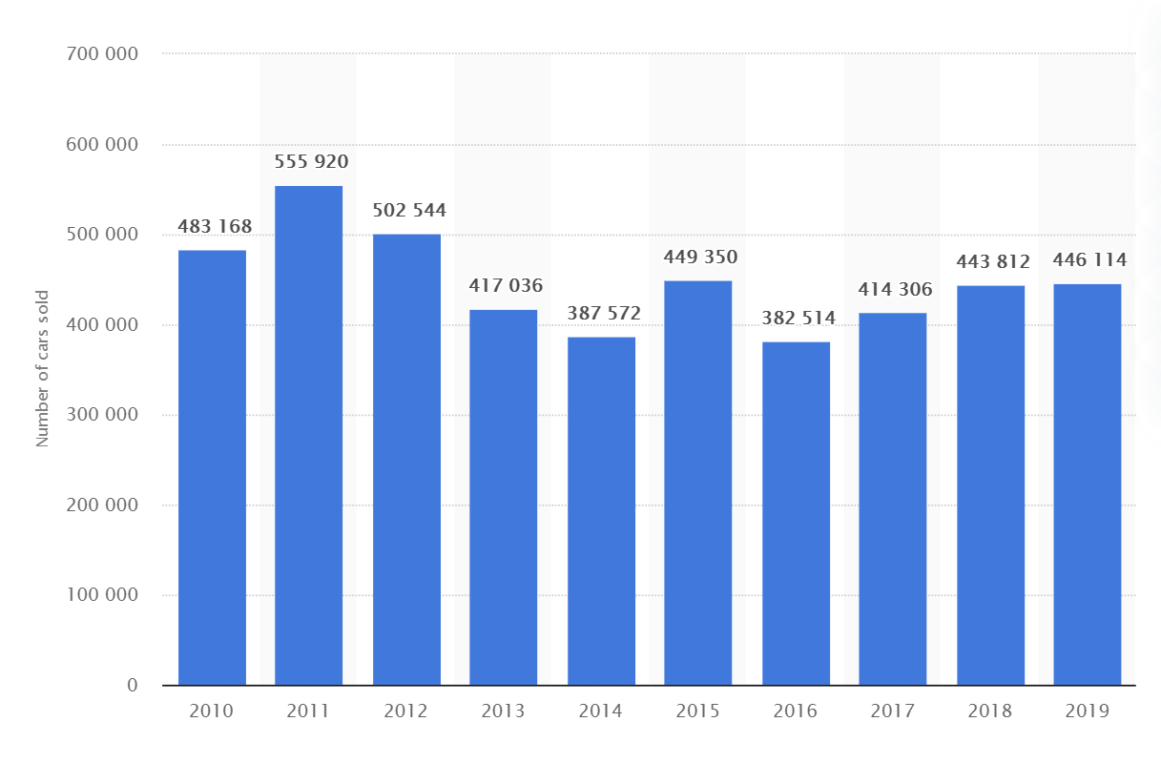
Figure 10
Passenger Car Sales in the Netherlands by Fuel Type (Statista, 2021)
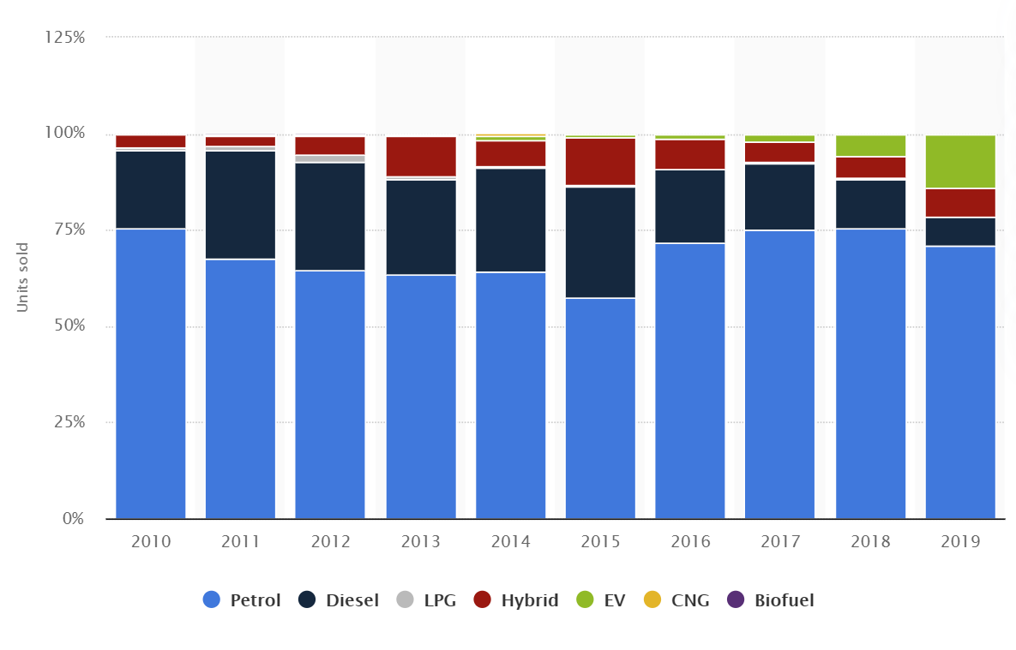

QGIS Results
With data collected during the research phase and with the help of QGIS, the following map, Figure 11, was produced. It indicates electric vehicle charging points in and around the Utrecht Heuvelrug region, and shows a radius of a 5 minute drive (around 4km) from these charging points. From the map, one can tell that the entirety of the Utrecht Heuvelrug municipality, indicated in blue on the map, is easily covered by these charging stations. Figure 12 also indicates the EV charge points, but overlays the area of the Utrecht Heuvelrug Park, which is also largely covered.
As can be seen in Figure 13, there are many bus stops around the region of Utrechtse Heuvelrug but not many that go through it. In most of the places where the bus stops are more sparse the frequency of the busses are also lower. People who commute to work often want to get there as fast as possible if they were to travel by bike; this means that the commuters' cycling paths should be thoroughly connected. As can be seen from our QGIS map of the region, Figure 14, with the commuter’s bicycle paths. You can clearly see that the density of these lines is significantly less than in other regions such as Nijmegen.
Figure 11
Radius of a 5 Minute Drive (4km) from EV Charge Points Around the Utrecht Heuvelrug Municipality (Blue Area)
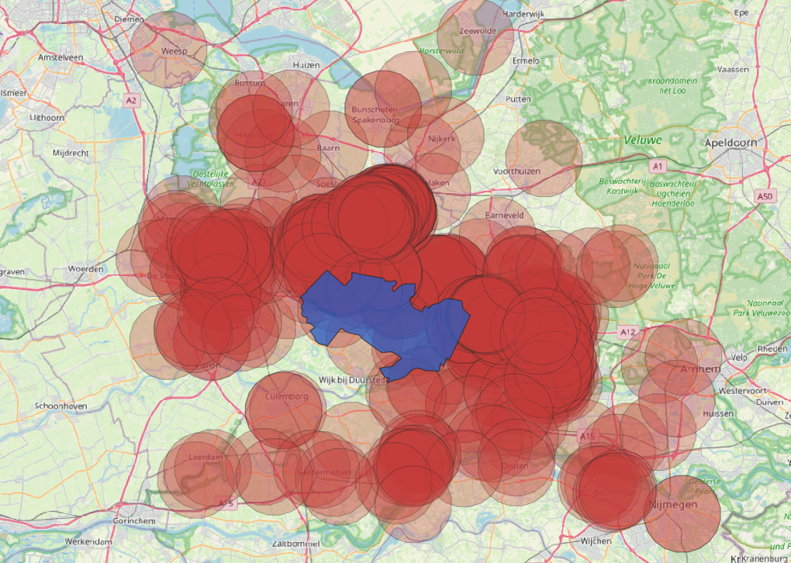
Figure 12
Electric Vehicle Charge Point Radius Overlaid Against the Area of the Park (Yellow Area)
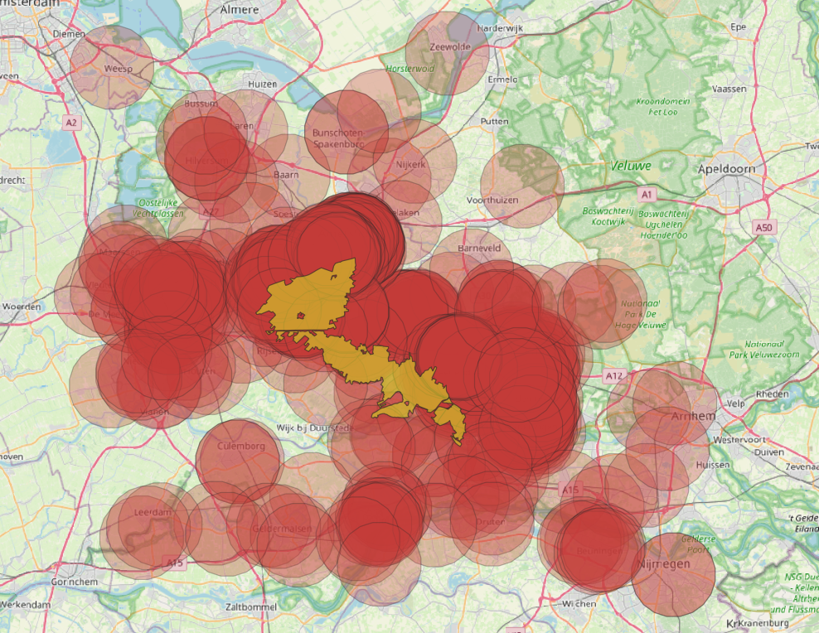
Figure 13
Utrechtse Heuvelrug Region (in orange) as well as the Available Bus Stops in the Region (green circles with H)
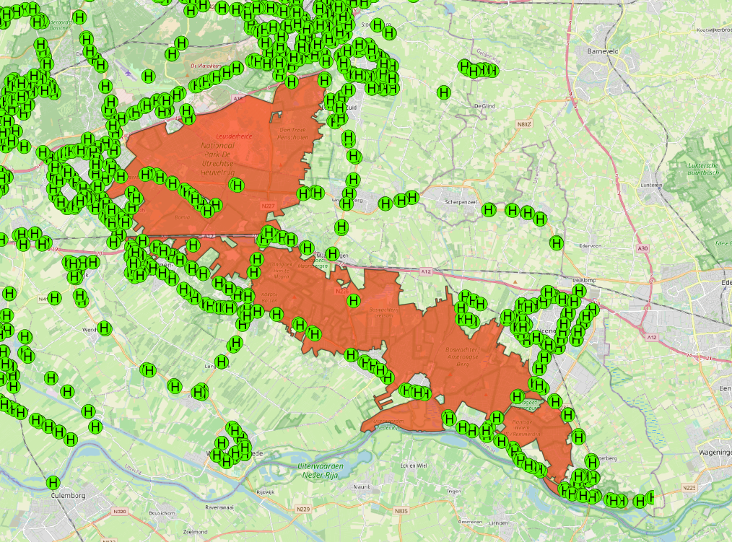
Figure 14
Density of Commuter’s Cycling Paths in the UH Region and its Surrounding Regions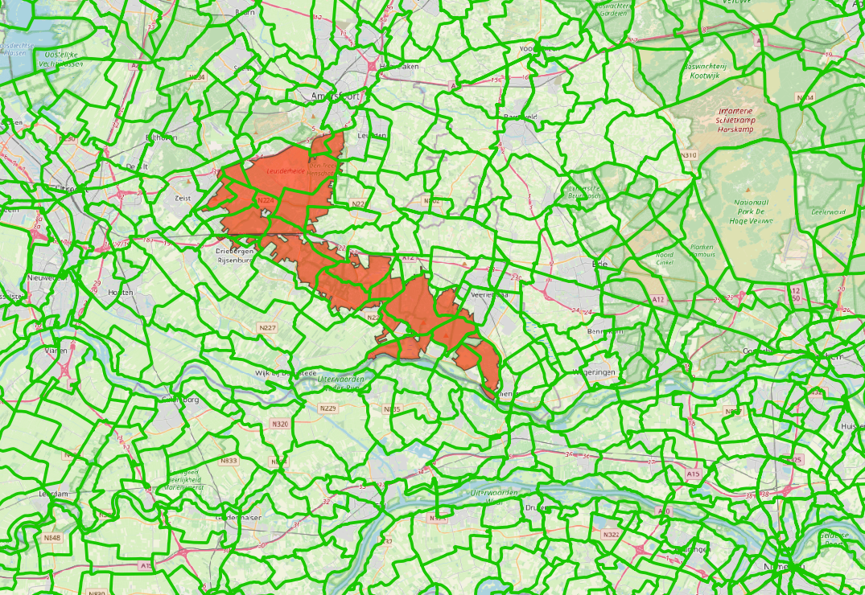
Discussion
In the following section, the results will be discussed and looked back at in conjunction with the targets that were introduced in the introduction and make up the foundation of this report. Moreover, discussing the results with respect to the targets will create a foundation for the eventual conclusion and recommendations.
Reducing Motorised Traffic
Motorised traffic refers to any mode of transport which is made up of an engine. The idea of reducing all motorised traffic has come about as part of a European movement, the landscape, to reduce the amount of vehicles on roads, notably vehicles owned by individuals, and to push towards other modes of transport, such as cycling or walking, and to more environmentally-friendly modes of transport, such as public transport.
However, motorised traffic has become such a vital part of society and has continued to progress and increase in significance. For this reason, a shift to other modes of transport can be seen as an unrealistic and counter-intuitive idea. As seen in the results section, a large part of road users are already using public transport more often than a privately-owned motorised vehicle. This same source also showed that the majority of people use privately-owned motorised vehicles instead of public transport.
Motorised traffic has become the main mode of transport for most of the population in the Netherlands. Although cycling is the dominant mode of transport in urban areas, motorised transport remains the primary mode of transport for rural areas, such as Utrecht Heuvelrug, and other trips. Both of these regimes are essential.
The Netherlands is the world’s leader in cycling infrastructure but this does not make cycling the main mode of transport all the time. Bad weather, such as high winds and rain, is common in the Netherlands and leads to more use of motorised traffic. Also, although the Netherlands is a rather small country, travelling long distances is usually done through motorised transport rather than cycling.
The research conducted showed that the amount of passenger cars sold over the past 4 years has increased, with an increase in electric or hybrid vehicle sales from 0,7% in 2015 to 14% in 2019 (Statista, 2020). The research also found that from 1990 to 2018, emissions from motorised road traffic have decreased, from 192 million kgs in 1990 to 28 million kgs in 2018. There seems to be a strong correlation between the increase in electric vehicle proportion, which can be categorised as a niche, and the decrease in emissions. Other factors such as mechanical improvements in fossil-fuel cars could also be an explanation.
Inducing a Modal Shift: Public Transport
Private cars offer users the freedom to travel to and from wherever they want, at any time they choose. This freedom has enhanced personal mobility throughout history but has unfortunately resulted in an unsustainable transport system (Davidson & Knowles, 2006).
It has been found that the perceived benefits of private car usage by users is dependent on their lifestyle and social-spatial relations (Hiscock et al., 2002). A shift from private car usage to public transport will require an improvement in service quality, which is only achievable with a clear comprehension of travel behaviours, and consumer needs and expectations (Beirão & Cabral, 2007). In this study, it was found that people perceive public transport to be both more and less time consuming than private cars, travel time is significantly reduced in areas where there are bus lanes, and finding a place to park for private cars can also be time consuming.
Comfort is also considered a barrier; most private car users perceive public transport to be uncomfortable, too crowded, smelly, and airless. Public transport being too crowded seems to also be a disadvantage for public transport users.
Lastly, real-time public transport information such as routes and timetables is a barrier. Many private car users find this information difficult to find and navigate, and many public transport users find that it is not clear enough when a schedule has changed.
To make public transport more attractive, accommodating people who already use it as well as improvements to the system as a whole is needed. Making public transport more attractive can be achieved by looking at different aspects of the public transport system. It can be improved at specific sites (e.g. bus stations and bus stops), along routes and by looking at the available ‘bus product’ (Davidson & Knowles, 2006). Such changes include new ‘cleaner’ buses, passenger infrastructure and information, and vehicle priority. These improvements would introduce a more sustainable public transport system that would also be more efficient for travelers.
Inducing a Modal Shift: Cycling
Many private car users use their cars because it offers more freedom and comfort. In most cases, using a car is more time efficient than using a bicycle, and also offers greater comfort in bad weather situations. The level of exertion needed and the gaps in existing bike path networks are also barriers to a greater cycling use.
By mapping the existing bike lanes in QGIS, the research found that there are many gaps hindering the connectivity and therefore increasing the effort levels in public commute. The introduction of electric bikes onto the market offers commuters a faster way to reach their destination and solves the issue of exertion levels. In order for this option to be sustainable, there needs to be a sufficient amount of charging stations as well as safe and secure bicycle parking.
Shifting to 75% Electric Vehicles
The current electric vehicle mobility regime is unstable, the study has shown that there are two pertinent issues blocking the pathway to a more stable regime, reaching the above-mentioned target: the mental aspect of people being willing to shift towards electric mobility, and overcoming the fossil-fuel society that society has created. This latter issue is further accentuated by the amount of infrastructure required to shift electric cars from being a niche to a viable option to challenge the currently stable regime of fossil fuel mobility. In order to create the desired climate neutral landscape by 2035.
QGIS data found during the research process has shown that the infrastructure in the region is sufficient. Everyone inside the national park is within a 5 minute drive radius to at least one charging station; from which the conclusion is that the infrastructure should not be the focus of improvements in the future.
Survey data collected showed that only a small portion of all vehicles driving through the region are electric vehicles, a stark contrast to the ambitions of the municipality. However, survey data also showed that people in the region had a positive perception towards electric vehicles. Many people addressed a financial barrier to switching to an electric vehicle, whilst a smaller group stated that practicality reasons were the main barrier. All the negative perceptions of electric vehicles were made by fossil-fuel car drivers, which the report assumes could be due to a lack of information and knowledge regarding the topic.
In order to shift to a regime of electric vehicles, one must take into account the external landscape pressures, most notably that people need to be financially able to afford the vehicle, in addition to being willing to make the shift. Users who have made the shift to electric cars often argue that an electric vehicle is cheaper in the long run, as the electric fuel is significantly cheaper than fossil fuels (Van Vliet et al., 2011). Further research would have to be made to confirm this as a reality, which could potentially impact the decision making of people in a considerate manner.
Shifting to 25% Biogas Vehicles
Biogas is a type of renewable energy which can be extracted from decomposed organic matter. Aquatic biomass, such as algae, located on the water surface within the municipality is one of the most innovative sources (Royal HaskoningDHV., 2020). In 2017, bio-energy accounted for 2.2% of the total energy consumption in the province of Utrecht.
There are 33 major bio-energy related projects in the province, as can be seen in Figure 15. Biogas infrastructure, like specialised charging stations, is still lacking in the region which could hinder the development of biogas vehicles in the future. It is clear that biogas is still in the initial development stage which can be considered a niche that is emerging in the transportation system. The major barrier of popularizing biogas is the availability of biogas vehicles. Biogas vehicles are not widely spread in B2B transactions in the Netherlands and have not reached the B2C market. In addition, in order to increase the accessibility of biogas to consumers, the infrastructure, production and expansion of the biogas sector are necessary.
Figure 15
Major Bio-Energy Related Projects in the Province (Royal HaskoningDHV.,2020)
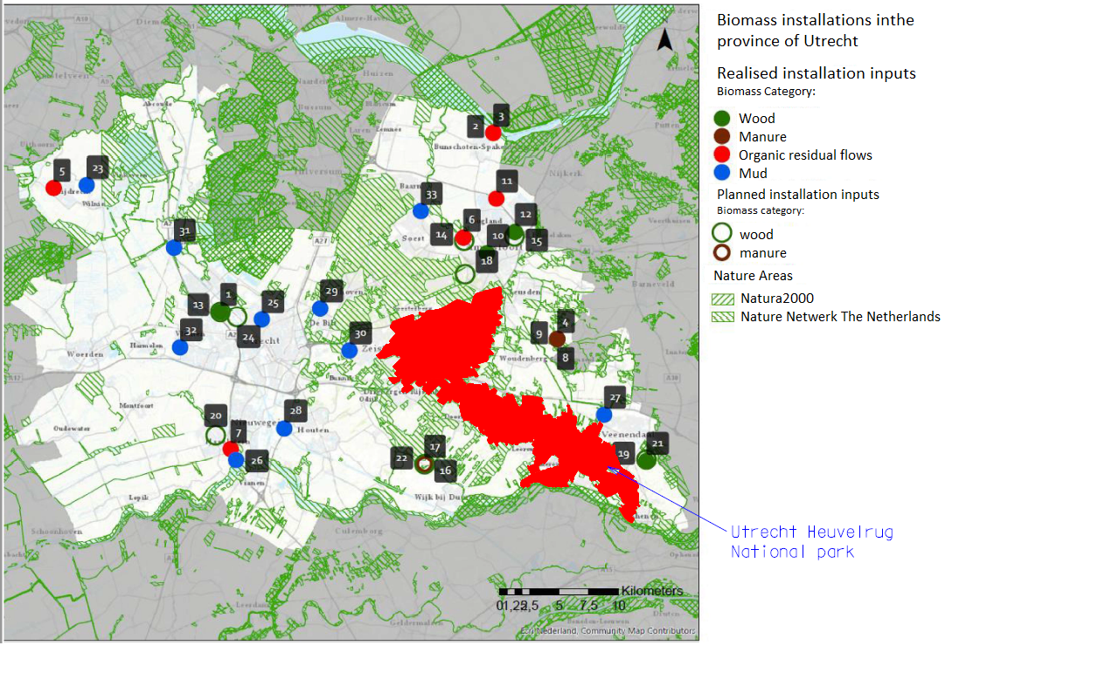
To facilitate the spreading of the use of biogas, pressure from the landscape should be increased. This can include legislation, infrastructure development and subsidies from the government. There are several small companies that produce biogas but their production scale has to be increased in order to fulfil the requirement of reaching the mobility goals in 2030. According to Ammenberg, J, biogas is more preferable for long distance of travelling compared with electricity (Ammenberg, J., 2018). It can be used for public transport with long traveling distance while ensuring the supply of electricity for EV within a town.
Improvements
Furthermore, another discussion issue is possible missing or biased data. To start with the possibility that the collected fieldwork survey data might have been too little in order to come to definite conclusions about people’s perceptions on the research topics, since a mere number of 24 people actually did fill in the surveys. To elaborate on this matter, the surveys were conducted during a weekday (tuesday), which was the cause of a limited flow of visitors. As a result, most of the people who visited the park were elder, retired people, this also brought about the problem that these people had insufficient digital knowledge, making it harder to explain and conduct the research.
Moreover, the counting data that was gathered during the fieldwork in order to analyze the distribution of vehicle types in the region might be biased, since the students performing the research did not recognize many different types of electric vehicles, besides electric vehicles from Tesla. It is possible that many electric vehicles were missed causing the counting data to have some flaws.
Conclusion
The report evaluated the current infrastructure of the Utrechtse Heuvelrug region in order to determine whether it is achievable to meet the 4 mobility targets set out to achieve climate neutrality by 2035 in the region. By combining previously available research, collecting data during fieldwork, and analysing other sources, the report came to a number of conclusions and recommendations.
First, the major reason for the slow transition towards electric vehicles is the high initial purchase cost, which is a barrier for the majority of people. Moreover, it appears that the necessary infrastructure to reach the targets is already in place, however, it can still be improved by building more charging stations and car parks. Finally, the percentage of electric cars bought is increasing yearly, indicating a slow but steady transition towards electric vehicles.
Second, biogas vehicles are still in the early stages of development with a lot of room for improvement, including the expansion of the biogas sector, production and infrastructure. The lack of choice of biogas vehicles, insufficient infrastructure, and the non-informed general public have hindered the development of the biogas sector. Although the current level of consumption in biogas is already around 70% of the target consumption rate, the potential of biogas vehicles should be increased with better infrastructure to support the transition in order to render it accessible to the general public within the region. In addition, more research and development should be invested in the sector to lower the cost of the technology and make it more accessible to the general public.
Regarding cycling, many people find it a tiring mode of transport meaning that the shift from motorized transport to cycling is likely to be minimal. There is also a problem with the weather, since most cyclists are not willing to bike through bad weather. To increase cycling in the region a few areas are fundamental; first, better biking infrastructure will increase the amount of cyclists amongst those who were already willing to cycle but did not find it efficient enough, and second, the introduction and advertisement of electric bikes, which will make cycling more attractive.
Public transport is a great option as an alternative to private transport if certain improvements are put into place. Many people who do not use public transport as their main form of transport seem to have the most negative perception of it. On the other hand, people who use public transport have a much more positive perspective. Some improvements can make this mode of transport more attractive to a larger number of people.
All in all, the report suggests that the reader takes away the following points: more information and infrastructure needs to be made available for the development of biogas and electric vehicles, public transport needs improved infrastructure, and cycling infrastructure requires an improvement in network connectivity in the region.
Relevance and Integration Possibilities
We expect that the results, collected both through surveys and fieldwork, will help enrich the existing datasets and allow the report to come to a conclusion regarding the research question. By having both technical and social data points, the report is able to analyse how mobility users feel about the current infrastructure and policy targets. The report expects that there will be an even split between practical reasons, such as people not being able to afford a new electric car or a lack of public transport stops near their home, and social reasons, such as being too apathetic to walk or cycle.
The results that have been found and analysed will be especially important to the municipality who set up the sustainability targets in the first place, however, other municipalities or regions in western-Europe who cope with similar situations will also be able to use the research results in order to overcome sustainability mobility issues. Additionally, the fetched results and conclusion that this research report has produced provide information as to how sustainable mobility can be incentivized, what the current perceptions of people in an average Dutch town are towards several mobility topics, and how what influences people to become more aware of and attracted to sustainable mobility.
The reporting group has already noticed and spoken about the connection to the students who have been studying subtopic 5D, which entails the sustainable mobility for residents. Both groups, 5C and 5D acknowledged the importance and connectivity of both topics to their own research, therefore, the groups have shared their survey data and results. The reasoning behind the cooperation with group 5D was that they had done research to residents, who also play a big part in this research report, since residents also visit, make use and even live in the national park, thus they are important stakeholders to improve the overall sustainability in the region. Furthermore, there will be connections with data from subtopics 2E and 2F, which both encompass the mobility preferences of residents and visitor mobility, topics that strongly correlate with the social component of the attempt to let people shift towards sustainable mobility in the region. Far more (sub)topics can be thought of which would relate to this research report, from social matters to technical difficulties such as; the possibility/feasibility to downscale current petrol industry, how infrastructure issues in the region can be solved, etcetera.
It has become clear that an interdisciplinary approach is necessary to answer the overarching research question for two main reasons: first, the report is looking at all users of roads in the area, which entails a wide range of different social aspects and possibilities, secondly, by looking at sustainable mobility, the report is looking at different modes of transport, and focusing on the technical details of them, including infrastructure. It would be ignorant to focus on either one of these aspects without looking at the bigger picture.
References
CBS. (2021). Emissions to air on Dutch territory; mobile sources. [Data set]. Opendata.cbs.nl https://opendata.cbs.nl/statline/#/CBS/en/dataset/84735ENG/table?ts=1620372552111
CBS. (2012). Emission factors by vehicle category and year of construction; 2008. [Data set]. opendata.cbs.nl. https://opendata.cbs.nl/statline/#/CBS/en/dataset/80447eng/table?ts=1620373738457
CBS. (2015). Motor vehicles; overview per period and technological features, 2000-2012. [Data set]. opendata.cbs.nl. https://opendata.cbs.nl/statline/#/CBS/en/dataset/70071eng/table?ts=1620373627148
d'Amore, F., & Bezzo, F. (2016). Strategic optimisation of biomass-based energy supply chains for sustainable mobility. Computers & Chemical Engineering, 87, 68-81.
Davison, L. J., & Knowles, R. D. (2006). Bus quality partnerships, modal shift and traffic decongestion. Journal of Transport Geography, 14(3), 177–194. https://doi.org/10.1016/j.jtrangeo.2005.06.008
European Federation for Transport and Environment AISBL, & Todts, W. (2020). How many charge points will Europe and its Member states need in 2020.
Geels, F. [Transitions NEST]. (2020, July 23). NESTwebinar #3 Multi-level-Perspective [video] https://www.youtube.com/watch?v=Tm6xVb-TXgk&t=382s
Ewing, R., & Cervero, R. (2010). Travel and the Built Environment. Journal of the American Planning Association, 76(3), 265–294. https://doi.org/10.1080/01944361003766766
Gemeente Utrechtse Heuvelrug. (2020). Héél véél informatie over Utrechtse Heuvelrug (update 2021!). AlleCijfers.nl. https://allecijfers.nl/gemeente/utrechtse-heuvelrug/
Gemeente Utrechtse Heuvelrug, & Vlug, S. (2010). Gemeentelijk Verkeers- en Vervoerplan Sturen naar duurzame mobiliteit. https://www.heuvelrug.nl/_flysystem/media/gemeentelijk_verkeers-_en_vervoersplan_gvvp.pdf
Gyimesi, K., & Viswanathan, R. (2011). The shift to electric vehicles. IBM Institute for Business Value.
https://www.ibm.com/downloads/cas/R6AZDA8E
Handy, S., Cao, X., & Mokhtarian, P. (2005). Correlation or causality between the built environment and travel behavior? Evidence from Northern California. Transportation Research Part D: Transport and Environment, 10(6), 427–444. https://doi.org/10.1016/j.trd.2005.05.002
Harrabin, B. R. (2018). Survey: Half of young people want electric cars. BBC News. https://www.bbc.com/news/science-environment-44798135
Höhne, N., Den Elzen, M., & Admiraal, A. (2015). Analysis beyond IPCC AR5: Net Phase Out of Global and Regional Greenhouse Gas Emissions and Reduction Implications for 2030 and 2050. NewClimate Institute, PBL Netherlands Environmental Assessment Agency, The Hague, ACT, 201(5).
Kreps, B. H. (2020). The Rising Costs of Fossil‐Fuel Extraction: An Energy Crisis That Will Not Go Away. American Journal of Economics and Sociology, 79(3), 695-717.
International Renewable Energy Agency. (2021). Electric Vehicles. Irena.Org. https://www.irena.org/transport/Electric-Vehicles
Nykvist, B., Withmarsh, L. 2008. A multi-level analysis of sustainable mobility transition: Niche development in the UK and Sweden. Technological Forecasting & Social Change, 75, 1373-1387. https://doi.org/10.1016/j.techfore.2008.05.006
Provincie Utrecht. (2016). REALISATIEPLAN FIETS 2016–2020. provincie-utrecht.nl. https://www.provincie-utrecht.nl/sites/default/files/2021-01/realisatieplan_fiets_provincie_utrecht_2016-2020_1.pdf
Putman, & de Wit. (2017). Routekaart Klimaatneutraal grondgebied 2035. Gemeente Utrechtse Heuvelrug. https://simcms.heuvelrug.nl/_flysystem/media/klimaatroutekaart.pdf
Rophol, G. 1999. Philosophy of Socio-Technical Systems. Society for Philosophy and Technology Quarterly Electronic Journal, 4(3), 186-194. https://doi-org.proxy.library.uu.nl/10.5840/techne19994311
Royal HaskoningDHV. (2020). Bio-energie in de provincie Utrecht. https://www.stateninformatie.provincie-utrecht.nl/documenten/Ingekomen-stukken-van-GS-naar-PS/Bijlage-1-1-Bio-energie-provincie-Utrecht.pdf
Statista. (2021). Volume of electric commercial vehicles registered in the Netherlands from 2015 to 2020. Statista.com. https://www.statista.com/statistics/940775/number-of-electric-commercial-vehicles-in-the-netherlands/
Statista. (2021). To what extent are you willing to take public transport more often instead of the car?. Statista.com. https://www.statista.com/statistics/827381/willingness-to-take-public-transport-instead-of-the-car-in-the-netherlands/
Unruh, G. C. (2002). Escaping carbon lock-in. Energy Policy, 30(4), 317–325. https://doi.org/10.1016/s0301-4215(01)00098
van Vliet, O., Brouwer, A. S., Kuramochi, T., van den Broek, M., & Faaij, A. (2011). Energy use, cost and CO2 emissions of electric cars. Journal of Power Sources, 196(4), 2298–2310. https://doi.org/10.1016/j.jpowsour.2010.09.119
Whitmarsh, L. (2012). How useful is the Multi-Level Perspective for transport and sustainability research? Journal of Transport Geography, 24, 483–487. https://doi.org/10.1016/j.jtrangeo.2012.01.022

Appendix
Appendix 1, an extended view at the literature review:

Theme | Type of data | Key observations: | Geographic scale
Infrastructure | - Cycling lanes and the cycling infrastructure in the region.  - Public transport situation in the region.  - Parking problem in the region right now.  - Public charging stations.  - Safety of transport in the region.  - Public transport bikes for rent.  Sources:  - Report of the municipality on sustainable mobility and transport (Vlug, 2010).  - Document/route card of the municipality on ambitions for a more sustainable future (Putman & de Wit, 2017).  - Provincial projects on the safety, efficiency and sustainability of cycling routes. | - The cycling infrastructure in the province of Utrecht is outstanding, but many improvements (mainly safety and efficiency) can be made to promote cycling (Provincie Utrecht, 2016).  - Public transport connections need to improve in order to reach the mobility goals (Vlug, 2010).  - Problem of limited (safe) parking spaces at the bus stops and train stations limits public transport (Vlug, 2010).  - More public bikes and cars need to become available (Putman & de Wit, 2017).  - Far more (public) loading poles need to become available in the region in order to incentivize electric vehicles, just like the EU has envisioned (European Federation for Transport and Environment AISBL & Todts, 2020). | - Data for particular municipalities in the region.
Emissions | - Emissions to air by road traffic and mobility on Dutch territory.  - Performance of all types of vehicles and specific fuel types.  - Emission factors by each type of vehicle.  Sources:  - Spreadsheets of CBS on total emissions in 2021.  - Spreadsheets of CBS on emissions per vehicle type in 2019.  - Spreadsheets of CBS considering emission factors and building year.  - Spreadsheets of CBS regarding the division of cars, nationally, per age group. | - Most parts of national and regional emissions come from road traffic. (CBS, 2021)  - Newer cars produce significantly less emissions, diesels are ‘better’ than petrol considering emissions (CBS, 2012). However, the largest part of cars, nationally, is 9 to 15 years old. (CBS, 2015)  - Electric and biofuel vehicles are not 100% clean, since the production of these energy types emit greenhouse gasses. (d'Amore, F., & Bezzo, F. 2016) | - Mainly national data
Current situation | - General mobility numbers for the Netherlands  - Types of vehicles as of right now in the Netherlands and for the specific region  - Situation in the region right now (regarding infrastructure, willingness to shift, plans, etc.)  Sources:  - Spreadsheets of CBS considering transport mode share and amount of kilometres driven (2021) per vehicle type in 2000-2012.  - Distribution of car type sold in 2010-2019 according to Statista.  - National distribution of usage of different transport modes in 2018, by the Dutch government.  - Distribution of car types (petrol and others) in the region in 2020.  - Multiple sustainability plans for mobility in the region. | - There are relatively less petrol cars in the region, in comparison to the national level, however, 80% of cars in the region are petrol cars, thus much effort is still needed to lower this number towards the set 0% in 2035. (Gemeente Utrechtse Heuvelrug, 2020) & (Statista, 2021)  - The number of electric vehicles in the Netherlands is rising exponentially and the number of electric vehicles sold as a percentage of the total amount of cars sold is rising even harder. (Statista, 2021)  - Only 10% of people are absolutely not willing to shift to public transport. (Statista, 2021)  - About half of ‘young people’ want to buy an electric car as their next vehicle, and only a quarter of their parents are willing to do so. (Harrabin, 2018)  - Many people are unwilling to shift to electric vehicles because they are wrongly informed (Gyimesi & Viswanathan, 2011). Better informed people, about the technical features of electric vehicles and the downside of petrol cars, will be more eager to make the shift towards electric cars. (Kreps, 2020) | - National data on distribution of cars  - Data on specific municipalities regarding infrastructure and future goals set
Possible  future | - Information about biofuels for transport, their possibility of becoming the next important fuel source for transport  - Possibility and probability of shifting towards electric cars/vehicles, and how to facilitate this change  - Possibility and probability of shifting towards biofuel cars/vehicles, and how to facilitate this change  - How to shift towards the use of more public transport in the region and away from commercial automobile use  - Biomass & Bioenergy potential in the province | - Biofuels and electricity have great potential for a more sustainable future. (International Renewable Energy Agency, 2021)  - Greatest obstacle in the transition will be to change people’s mindset and behaviour. (Gyimesi & Viswanathan, 2011)  - Infrastructure regarding loading poles for electric vehicles (and biofuel stations) needs to be improved in the region and nationally in general. (European Federation for Transport and Environment AISBL & Todts, 2020)  - Biofuel production needs to be upscaled in the region, since it was projected as an interesting option because of the forestry regions. (Gemeente Utrechtse Heuvelrug, 2010) | - Data on specific municipalities within the region  - General (European) data
Survey | - How to conduct surveys and how to use different types of surveys | X | X

